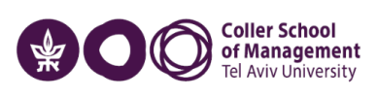
Host University Logo here

Personal Information
Full name:
Email:
Degree Program at TAU:
Host University:
Exchange term (including the duration):
Phone number (optional):
_____________________________________
Exchange Experience
Please use the outline below to write your report:
- About the country and city
- About the host university – campus and school atmosphere, location, staff attention and care.
- Courses and professors
- Extra curricula – orientation, social activities, student union, etc.
- Career center (if applicable)
- Business and Network Development
- Accommodation – dorms and other solutions
- Visa
- Transportation
- Insurance and health services
- Living expenses
- Food
- Night life
- Tips
- How did this exchange experience add value to your studies at Coller?
- Photos
Please note that the Coller School of Management may publish your report on its website. For any further information, please contact the Global Engagement Lead – Outgoing, coordinator@tauex.tau.ac.il

